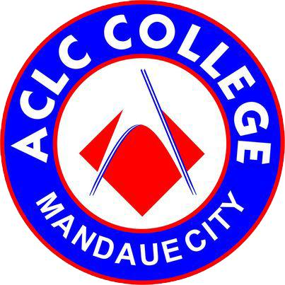
AMA Computer Learning Center College
M.C. Briones St, Mandaue City, Cebu
Telephone No:(032) 345 1237
Email: mandaueaclc@gmail.com

FurEver Home Pet Adoption

Marvin Awa
Jomari Ygot
Jinky Paciencia
John Jose Abad
Mary Rose Planga
Christian Darylle Lambojon

Bachelor of Science in Information Technology

Ms. Wilma Lyn Albarida
Instructor
January 2026
Introduction

A FurEver Home pet adoption is an organized platform that allows customers to choose and adopt pets while also giving them the option to surrender cats and dogs to an authorized organization. The system serves as a bridge between the organization and the public to ensure responsible and ethical pet management.
Through the system, customers can browse available cats and dogs, view their profiles, and apply for adoption based on their preferences and ability to provide proper care. At the same time, the system enables customers who can no longer care for their pets to safely surrender cats and dogs to the organization, ensuring the animals receive proper shelter, medical attention, and rehoming opportunities.
Overall, the FurEver Home pet adoption supports animal welfare by promoting responsible pet ownership, reducing stray populations, and ensuring that both adoption and surrender processes are handled in a safe, organized, and humane manner.

Scope:
The system allows users to create accounts and submit pet listings, while administrators review and manage the posts to keep the platform safe and organized. The main goal of the system is to make pet adoption and rehoming more convenient, accessible, and responsible using modern web and mobile technology.

Limitations:
The system focuses only on basic adoption and rehoming features. It does not include real-time messaging, automatic pet matching, or background checks for adopters. Health records and legal ownership of pets are not verified by the system.
All information provided on the platform depends on users, so some details may be incomplete or outdated. The system also requires an internet connection and may have limited features on mobile compared to a fully native mobile application.

